Proteonano™ HT Quality Statement (PQS)
Version: v1.0
Date: Feb. 8, 2026

Quality Control Summary for Samples and Plates
General description of quality control methods and performance outcomes for the Proteonano™ HT Plasma Proteomics Assay

1. Document Overview
Platform
Proteonano™ HT Assay
Calibration and QC System
PACS – Proteonano Assay Calibration & Standards
Application
High-throughput, large-cohort plasma proteomics
Client
XXXXXX
StudyID
XXXXXX
Date
MM/DD/YYYY
Intended Use
Research Use Only (RUO)

Document Purpose
This Proteonano™ HT Quality Statement (PQS) summarizes the quality control, calibration, normalization, and performance evaluation applied to samples processed using the Proteonano™ HT assay. The purpose of this report is to provide transparent, standardized documentation of assay performance across samples, plates, and analytical runs, supporting confidence in data quality, reproducibility, and cross-batch comparability.

2. Quality Control Framework Overview
The Proteonano™ HT assay incorporates a multi-layered quality control framework embedded directly into the 96-well workflow. Quality controls are strategically placed to monitor distinct sources of technical variability arising during sample preparation, plate-based processing, and LC–MS analysis.

Embedded QC Architecture
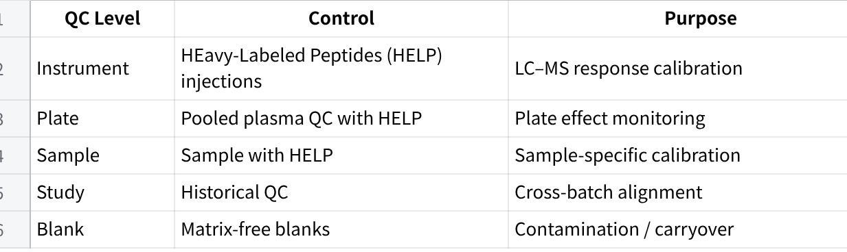
QC elements are embedded at their point of origin, enabling targeted correction rather than global post hoc normalization.

3. Calibration & Normalization Summary

Sample Summary
The table below summarizes the total number of biological samples and associated controls evaluated in this study, including pass and flag counts based on established quality criteria. Samples flagged by quality metrics are evaluated on a case-by-case basis to assess the appropriateness of normalization and their impact on downstream quantitative analyses.

Table: Sample & QC Summary
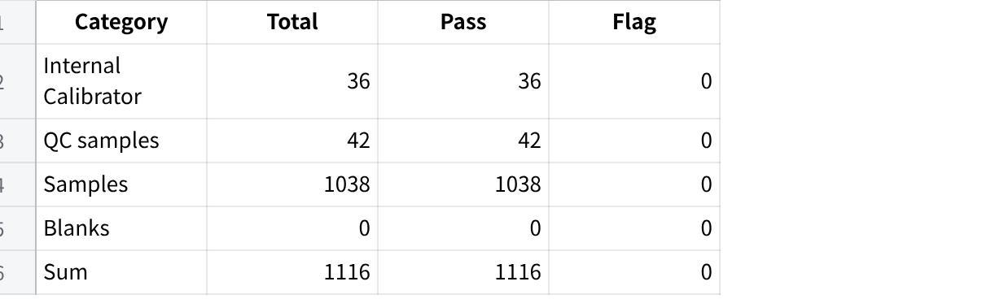

Quality Control Metrics & Flags
The table below summarizes the quality control metrics evaluated for the Proteonano™ HT assay, along with their corresponding acceptance criteria and assessment outcomes. These metrics are designed to monitor assay performance across sample preparation, plate-based processing, and LC–MS detection. Each metric is evaluated independently, and results are reported as pass or flag based on predefined thresholds. Metrics that fall outside acceptance criteria are flagged for review rather than automatically excluded, allowing informed decisions based on normalization performance and study context.

Table: QC Metrics and Acceptance Criteria
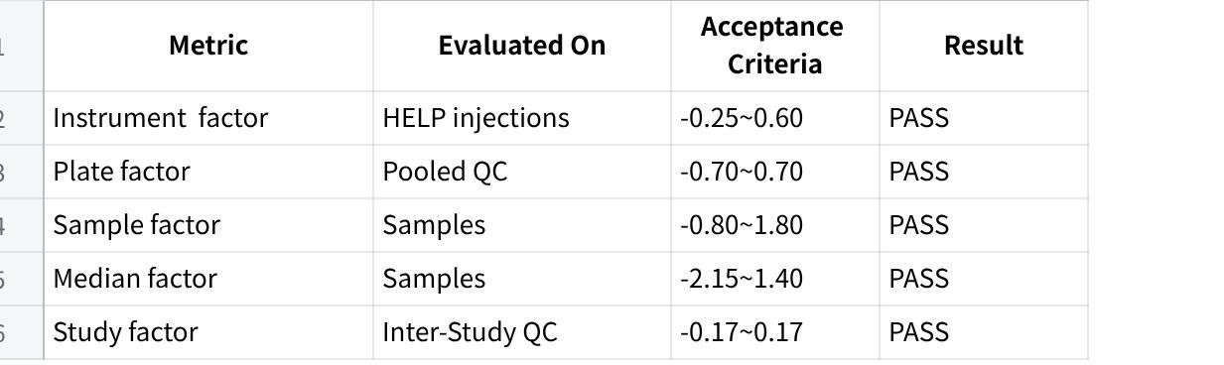

Plate-Level Normalization
Plate Scaling is derived from the median of reference signal ratios calculated from pooled plasma QC samples distributed across each plate, yielding a single plate-level scaling factor applied uniformly to all samples on the plate. This scaling primarily reflects systematic variability introduced during plate-based processing, including liquid handling performance. The plate scaling factor acceptance criteria is defined as -0.64–0.66 per plate.

Plate scaling factors were within predefined limits, indicating stable plate-based processing.

Sample-Level Calibration & Normalization

Sample-level calibration factors were evaluated across all study samples to assess normalization performance and signal consistency. Individual sample scale factors are summarized using distribution-based metrics and pass/flag counts rather than reported individually. This approach provides a robust overview of sample-level performance while avoiding over-interpretation of isolated sample-level variability.
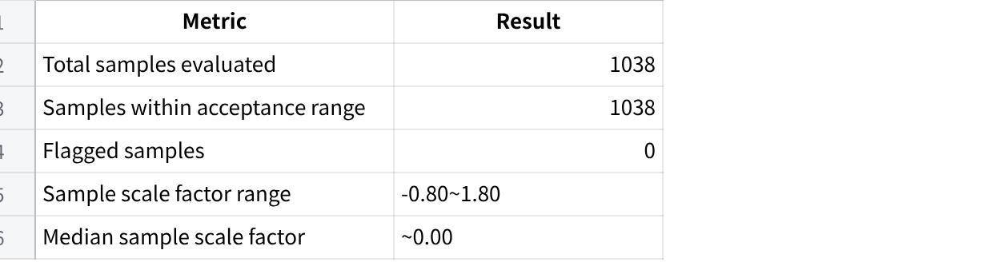

Inter-Study Normalization
Inter-study normalization is applied to evaluate and align signal scale across independent cohorts processed at different times or under different analytical conditions. Historical PACS reference distributions are used to assess whether systematic shifts in signal intensity are present at the cohort level. When deviations exceed predefined thresholds, an alignment factor is applied to harmonize cohort-level signal scale while preserving within-cohort relative abundance patterns.

Inter-study correction status: on/off
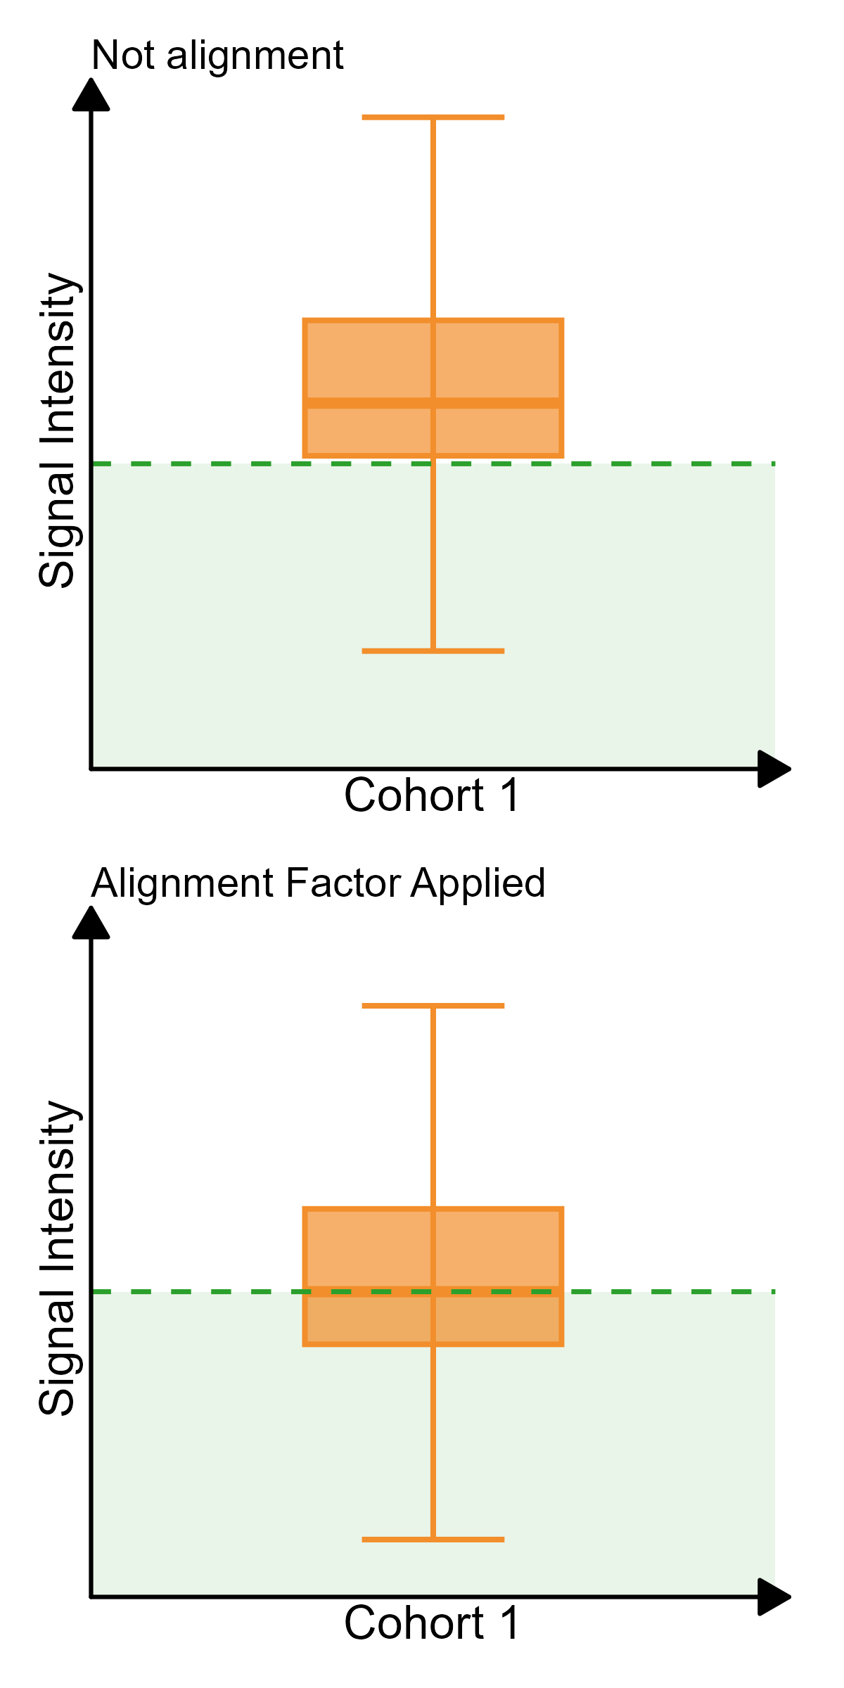

Contamination Filter
An optional contamination filtering step is implemented to identify samples exhibiting signal patterns consistent with unintended blood- or platelet-related contamination, which may introduce non-target signal contributions. Such effects can arise from variability in sample collection, processing-related artifacts, or analytical carryover. The filter evaluates predefined contamination signatures and flags samples exceeding established acceptance criteria. Flagged samples are reviewed and may be annotated or excluded prior to downstream analysis, depending on study design and quality requirements. This filtering step is optional and applied at the discretion of the study.

Contamination Filter Status: on/off
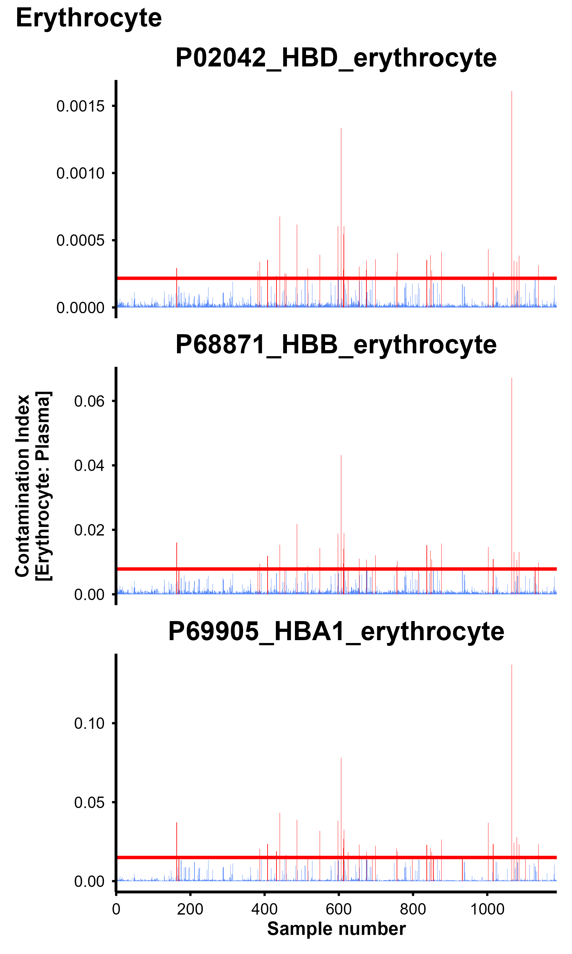 | 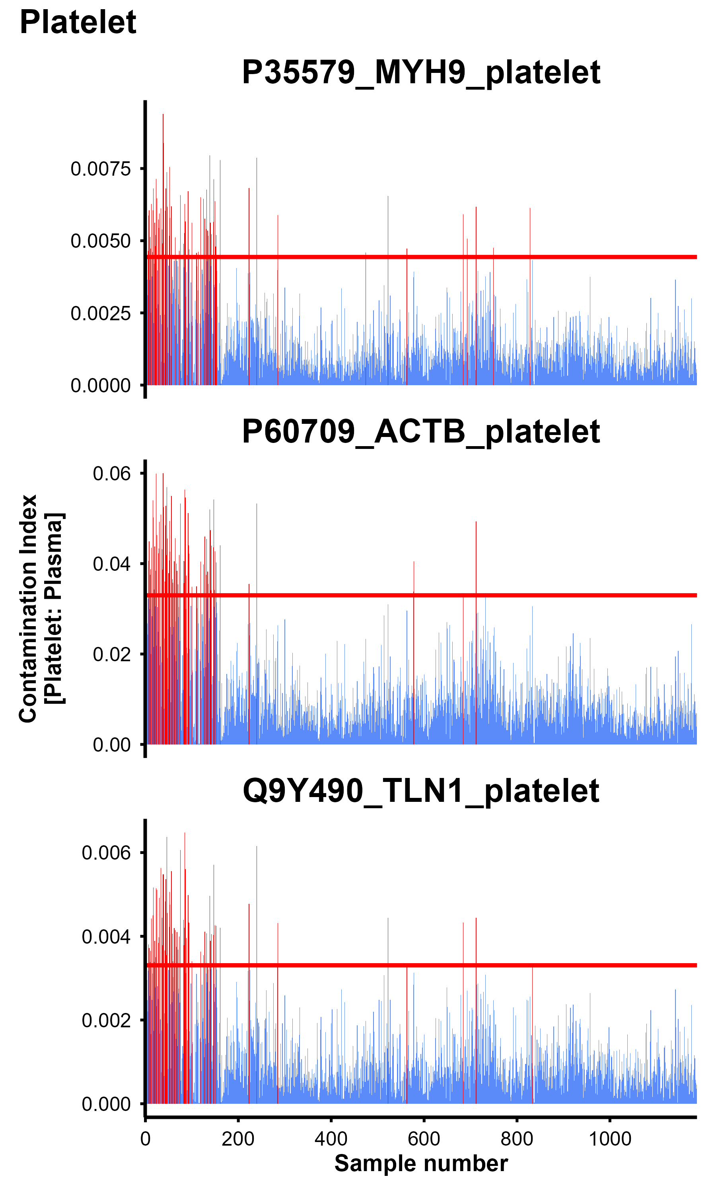 | 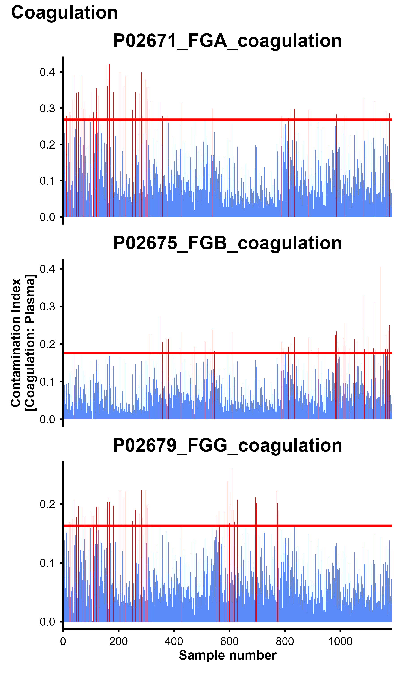
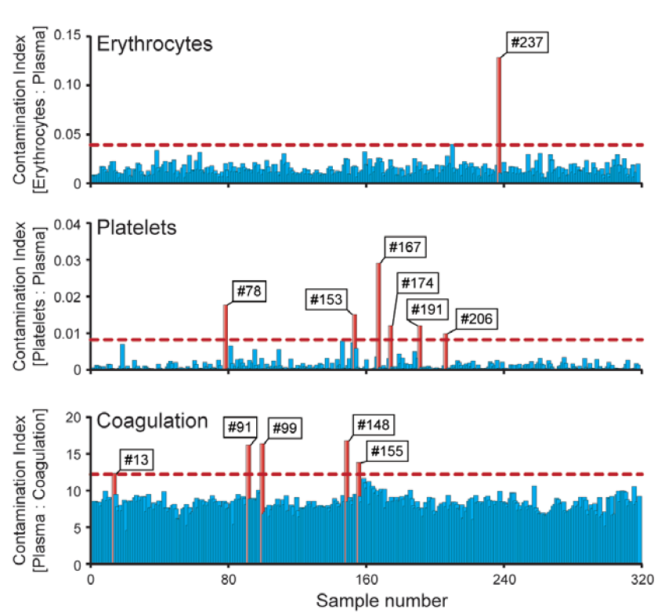

The quality of each sample is assessed based on three contamination indices. Samples with contamination index values exceeding two standard deviations from the mean (indicated by the horizontal red lines in the figure) are flagged as potentially contaminated (red bars). For detailed information, please refer to the Contamination report in the results summary table.

Acceptance Criteria
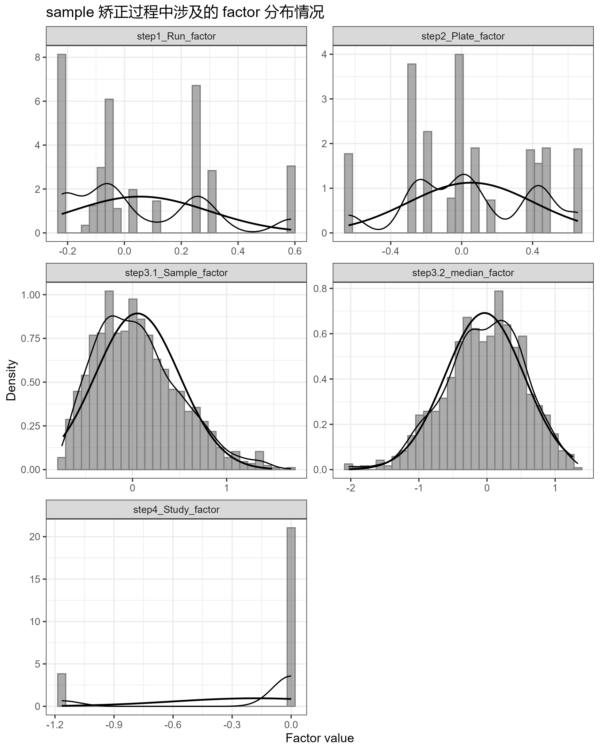
Histogram and kernel density estimate with fitted normal density overlay

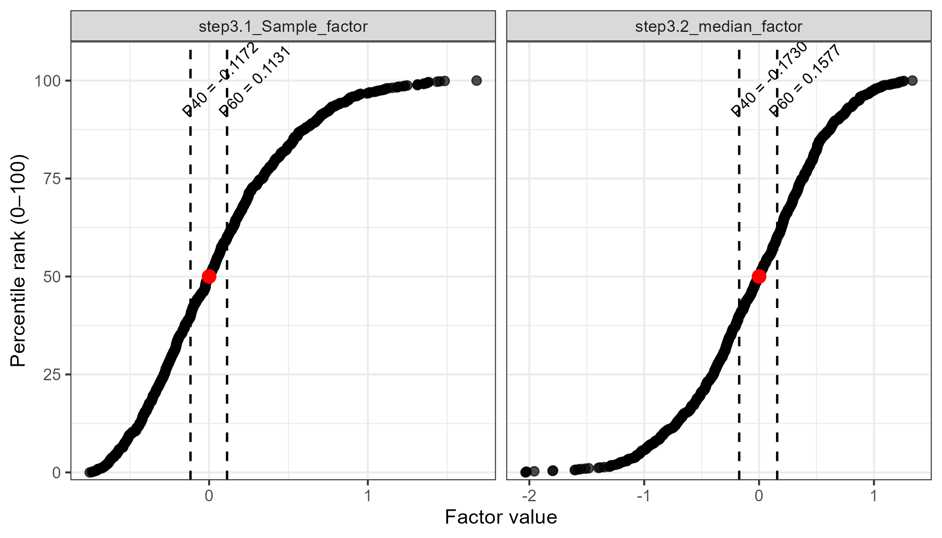 | 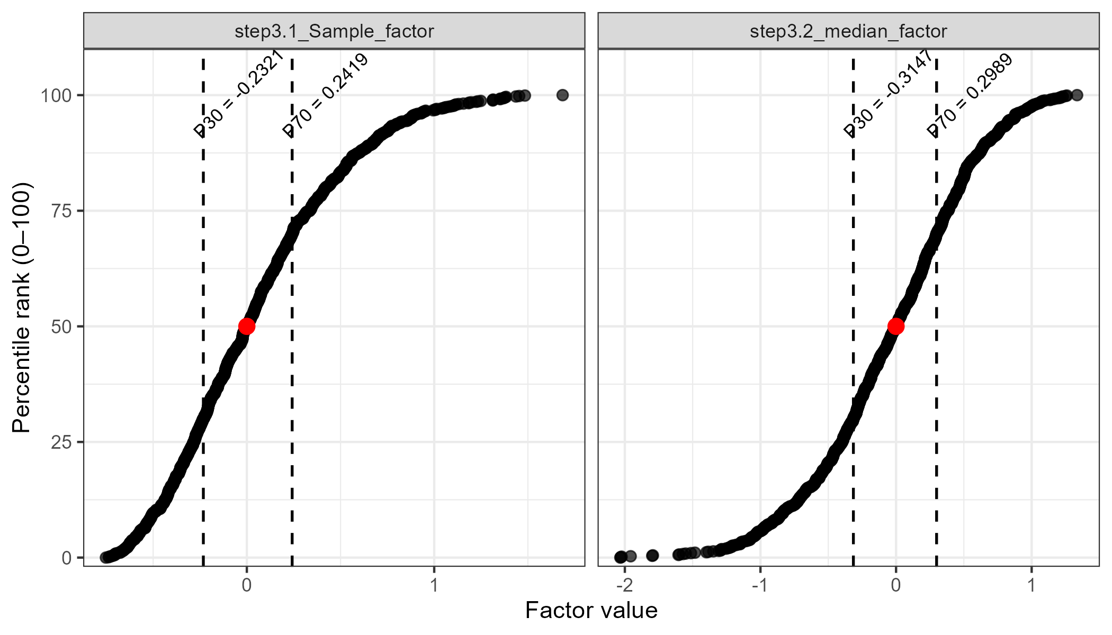
step3.1 & step3.2 factor / percentile rank

